**Module 4 – Test driven development and Logging framework**

**Mockito Hands-On Exercises**

**Exercise 2: Verifying Interactions**

**Aim:**

To ensure that a method is called with specific arguments.

**Structure:**

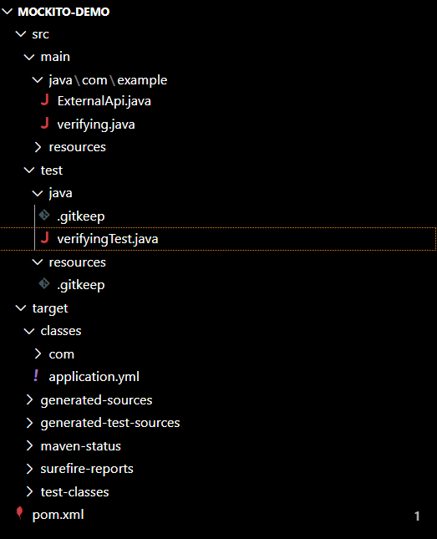

**ExternalApi.java:**

package com.example;

public interface ExternalApi {

    String getData();

}

**verifying.java:**

package com.example;

public class verifying {

    private ExternalApi externalApi;

    public verifying(ExternalApi externalApi) {

        this.externalApi = externalApi;

    }

    public String fetchData() {

        return externalApi.getData();

    }

}

**verifyingTest.java:**

package com.example;

import org.junit.jupiter.api.Test;

import static org.mockito.Mockito.*;

public class verifyingTest {

    @Test

    public void testVerifyInteraction() {

        ExternalApi mockApi = mock(ExternalApi.class);

        verifying service = new verifying(mockApi); // use your class here

        service.fetchData();

        verify(mockApi).getData();

    }

}

**Output:**

